The purpose of this procedure is to ensure the efficient and fair use of the limited car parking spaces available and to maintain security within the college premises.
students holding blue badges (also exemptions apply on discretionary basis), who require a parking space due to their disability must apply for a parking permit by completing this form and returning to the College Welfare Officer at welfareofficer@mrcollege.ac.uk.
Please note that only nine (9) car parking spaces are available.
If all nine allocated spaces are occupied, parking permit holders must park off-site. Students are reminded that parking in unauthorised spaces may result in their vehicle being clamped.
Thank you for your cooperation.
1. Car Parking Space Allocation
Eligibility:
Parking spaces are allocated on a means-assessed basis, primarily considering welfare and access needs. Allocation is also determined on a first-come, first-served basis.
Only students with a valid, current, and officially allocated parking permit are eligible to park in the designated nine (9) spaces.
Confirmation of a successful allocation, including the assigned parking space number, will be communicated via email.
2. Use of Allocated Parking Space
Permitted Use
Only the registered vehicle nominated in the parking permit application may use the allocated parking space.
Parking Regulations
Vehicles must be parked fully within the designated lines of the allocated space. Double parking or occupying more than one space is strictly prohibited.
3. Consequences of Non-Compliance
Reallocation
Upon cancellation of the car permit, the parking space will be reallocated to another eligible applicant.
Disciplinary Action
Repeated violations, such as persistent occupying multiple spaces, may lead to further disciplinary actions, including suspension of parking privileges for the remainder of the academic year.
The 9 Allocated Car Parking Spaces Are Located On The LEFT-HAND Side Of The Car Park Entrance. |  |  |  |  | 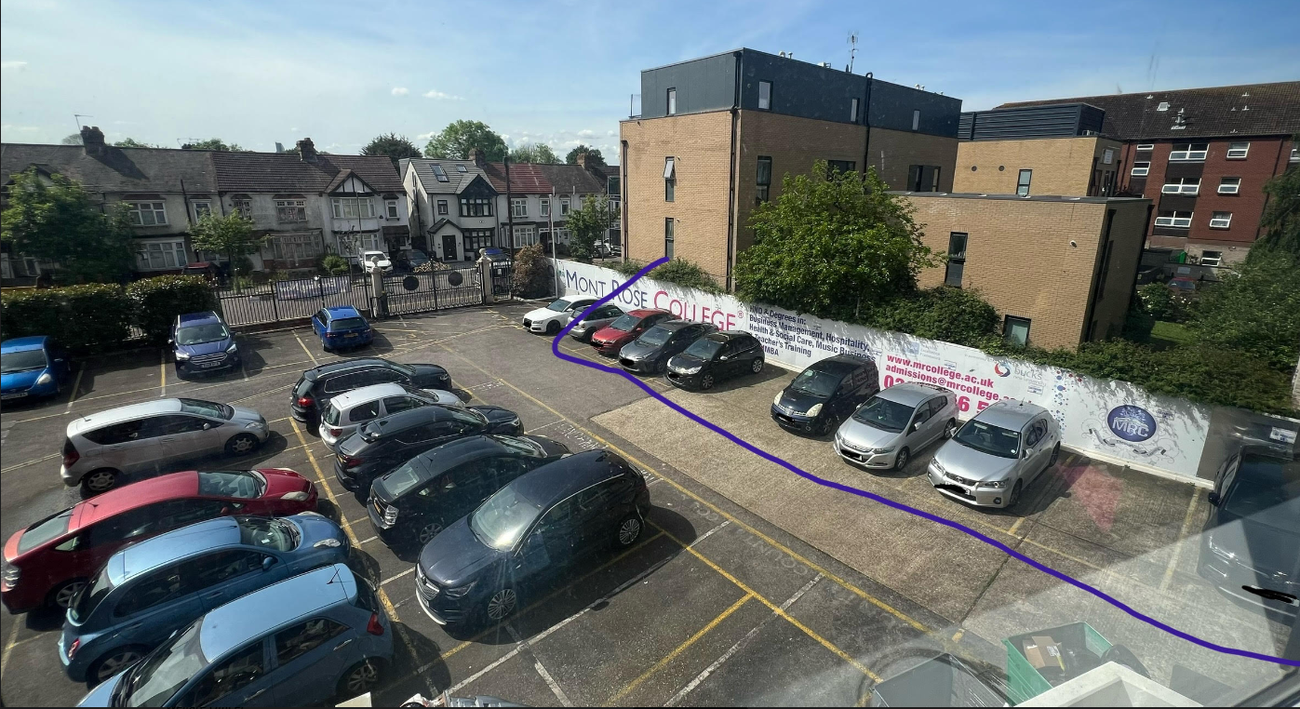
Declaration: By Submitting This Form, I Certify That I agree fully with the stated conditions of car Park usage and will comply fully with all conditions.
Student Name |  |  | ID No.
Signature |  |  | Date:
Staff Name
Signature |  |  | Date:

